FROM OUR WOLFPACK
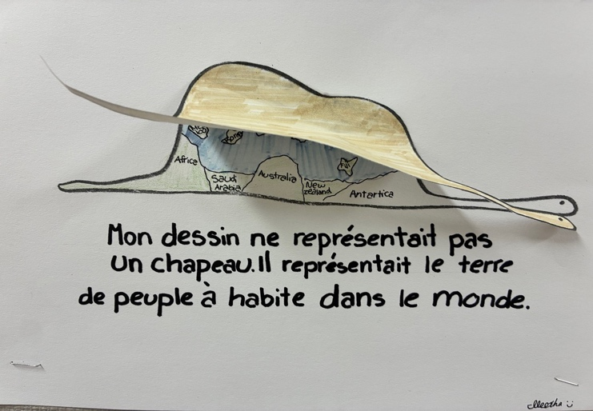
Inspired by the iconic "hat and elephant" imagery from Le Petit Prince, Division 1 explored the power of imagination and perspective through art. Students created their own drawings that challenged viewers to look beyond what is immediately visible and consider different interpretations. Through this activity, students learned that creativity often comes from seeing the world in unique ways and that there can be more than one way to understand a story, image, or idea. Please see below for Aleesha and Alfie’s interpretations.

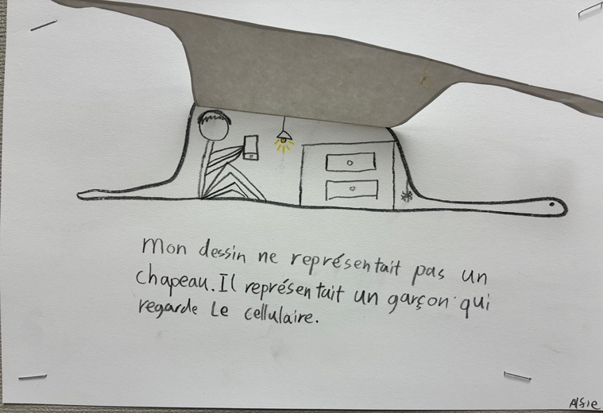

Last Day of School and Summary of Learning
Your child’s final report card for the school year will be posted on MyEdBC on the last day of school, June 24th. Additional information will be sent from the district about accessing reports on MyEdBC. School will be dismissed at our regular time of 2:45 p.m.

Back to School Information
Grade 1 – 7 students return to school from 10:00 a.m. – 11:00 a.m. on September 8th. More information will come in an email prior to the first day of school. Please expect one by September 4th.
Kindergarten students begin their gradual entry from 9:00 a.m. – 9:45 a.m. or from 11:00 a.m. – 11:45 a.m. depending on which group that they have been assigned to. They will meet their teacher at the front entry door of the school. Gradual entry schedules and information have been sent last week.
All Gr. 1-7 students will attend for their regular schedule on Wednesday, September 9th at 8:45 a.m.
PAC MEETINGS
Our final PAC meeting and AGM was held on June 16th, 2026. We are extremely appreciative to all their hard work over the course of the 2025-2026 school year!

We congratulate our new Whiteside PAC of the 2026-2027 school year:
Co-chairs – Sandeep Bhullar and Sofia Shivji
Treasurer – Jaylene Sandhar
Secretary – Carrie Viloria
Hot Lunch Coordinator – Karen Au
Social Media and Communications – Chris Ho

Farewell to Staff
Unfortunately, June is also the time of year that we have to say goodbye to some of our staff. This year, we will say goodbye to Ms. Masaki (Gr. 5/6), Mme Cheng (Gr.2/3 EFI), Ms. Su Lee (EA), Mrs. Sharon Lee (EA), Ms. Gao (SLP), Ms. Tolfo (counsellor), and Mrs. Nasir (Noon Hour Supervisor). We hope that our paths will cross again and wish them all the best in their new endeavours.

LETTER OF LATE RETURN AND EXTENDED ABSENCES
If your child is not able to attend school on Tuesday, September 8, 2026 (the first day of school), but will be returning on or before Friday, September 11th, please complete the Letter of Late Return with the reason for late return to whiteside@sd38.bc.ca by Thursday, June 25th. (Hardcopy forms can be picked up from the office if you do not have a printer.)
Please be advised that the expectations regarding extended absences are different at the beginning of the school year. While extended absences of 20 consecutive school days will normally be considered by the school, the student must be in attendance during September for provincial funding purposes.
If a student does not return on or before Friday, September 11th, we cannot guarantee his or her spot at Whiteside. We are considered a full school and have students in our community on a waitlist. If you arrive after the expected date, your child may need to re-register and be placed at another school upon his or her late return.
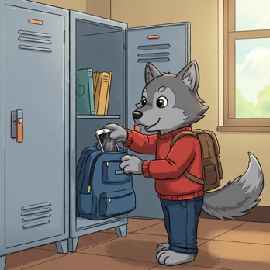
DIGITAL DEVICE POLICY
In January 2024, the Ministry of Education and Child Care mandated all school boards in British Columbia to update their Codes of Conduct to include restrictions on students’ personal digital device use. Students should not have personal digital devices (phones, tablets, smart watches, or computers) in their possession during the school day unless permission is granted by the supervising staff for educational purposes. This includes during recess and lunch or while outside on the playground or on school property. It is recommended that students do not bring personal digital devices to school.


ALLERGY ALERT:
All families should be aware that Whiteside School has many students with severe, life-threatening food allergies. Some classrooms may be designated nut free to protect the health of these students. Please help us limit the nut products entering our school overall, as the impact on a student can happen anywhere in the school. If possible, please do not send food to school containing nuts.


MORNING ROUTINES AT WHITESIDE
Our Wolfpack are expected to enter
school from their outside doors until 8:45 a.m. Please ensure that your children make their way to the back of the school to meet their teachers. This ensures that all children are met by their teacher or supervising adult and can begin the day with their class.
Play n’ Eat is on Friday mornings only. Students who arrive earlier than 8:40 a.m. are welcome to play on the playground or line up early.

KEEPING OUR COMMUNITY CLEAN
There has also been an increase in litter and refuse around our school and local community. We ask for your support in keeping our community clean. These are some ways you can help:
- Reuse reusable snack and lunch containers instead of single-use plastic bags, wrappers, and foil.
- Resuse reusable drink containers too.
- Send “boomerang” lunches – all uneaten food and packaging can be returned home.
- Talk with your children and lead by example:
    - Reinforce proper sorting of waste at home (recycling and compost)
    - Pick up in the park – help pickup litter around South Arm

Thank you for your help!
IMPORTANT DATES
June 25 – Spirit Day – Wear team colours
June 25- Summary of Learning reports published
June 25 – Final day of school for students
Sept 8 – First day back at school
Lost and Found
Please remember to check our lost and found before the end of the school year. There are still many water bottles, jackets, shirts, and much, much more remaining. All remaining items will be donated on June 26.

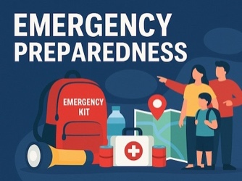
PARENT GUIDE TO EMERGENCY PREPAREDNESS Please visit our school website, whiteside.sd38.bc.ca, to view our district guide to emergency preparedness to better understand our district procedures, emergency drills, communication protocols, and the student reunification process.

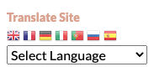
TRANSLATE OUR SITE
Did you know you can translate our whiteside.sd38.bc.ca website?

