FROM OUR WOLFPACK
Division 13 reflected on this beautiful Spring season. Take a look!

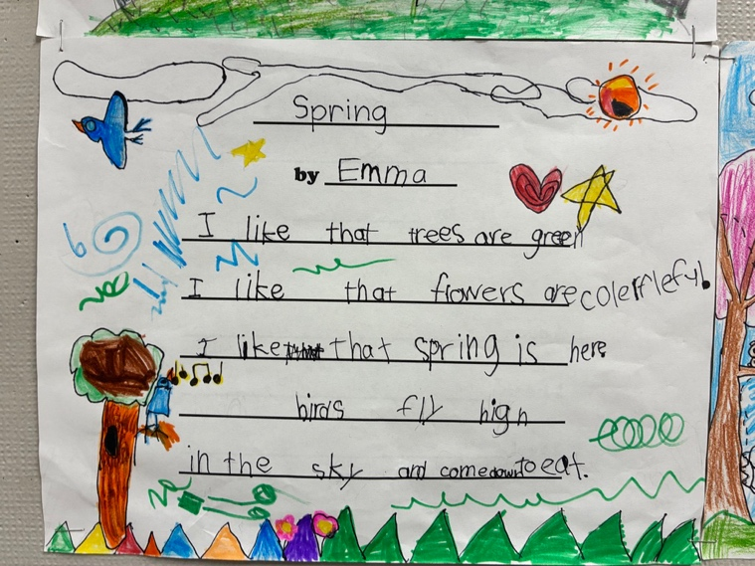

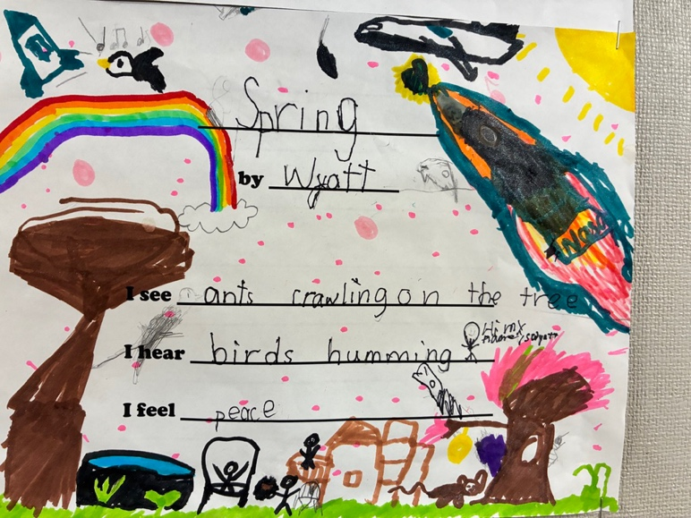

Movathon Fundraiser – Due June 5
Whiteside PAC is organizing a fundraiser to help beautify our school! Sandeep Johal, a renowned muralist, is going to be painting a mural inside the front entrance of the school. We are hoping that she continue this work in the gym as well. To help fund this project, students have brought home a pledge sheet to encourage exercise and movement for a good cause. There are prizes for the students and classes who raise the most funds. Let’s move for Whiteside!

2025-2026 Yearbooks Available Now!
Orders for yearbooks are due on Monday, May 25. Please go to School CashOnLine to order your copy of this year’s Whiteside memories. NO EXTRAS WILL BE ORDERED.

Class Placements and Organization for the 2026-2027 School Year
Our school staff will soon begin thoughtfully planning class placements for the upcoming school year, aiming to create the best learning environment for every child by considering academic, social-emotional, and learning needs, as well as class dynamics.
While specific teacher or friend requests cannot typically be met, parents are invited to share insights into their child’s ideal learning conditions regarding social, emotional, or academic needs. There is also the possibility of changes in our staffing or the levels that our staff teaches. If you wish to provide this valuable input, please email Ms. Lai by Friday, June 5th, 2026..
We appreciate your trust in our professional staff to organize classes for a productive and rewarding year for all students.
Parent/ Caregiver Appreciation Drive Thru
Thank you for your continued support of Whiteside and for partnering with us in making your child’s learning experience successful. We are truly a TEAM!
Please join us — or drive through the Whiteside parking lot — so our staff can show our appreciation for all that you do for our school community.
We look forward to seeing you outside the school on Friday, May 29 at 8:10 am.
This week’s Play N’ Eat will be cancelled in the gym.
New Principal Coming to Whiteside
It has been announced that Ms. Lesa Schulz will be Whiteside’s new principal effective July 1st, 2026. She is coming from Lord Byng Elementary where she has been principal. We are excited to have her come to Whiteside and join our amazing community.

Ms. Rooney will be moving on to Garden City Elementary as their new Principal. Ms. Lai will continue to stay at Whiteside Elementary as our Vice Principal.

IMPORTANT: HOT LUNCH VOLUNTEERS NEEDED
Thank you to our PAC for providing yummy hot lunches. We need more volunteers to join us on our PAC hot lunch days to organize and distribute the meals to our students. Without the hard work of this team, our hot lunches can’t happen. If you can help, please email our team at jameswhitehotlunch@gmail.com.


PARENT GUIDE TO EMERGENCY PREPAREDNESS Please visit our school website, whiteside.sd38.bc.ca, to view our district guide to emergency preparedness to better understand our district procedures, emergency drills, communication protocols, and the student reunification process.


SUMMER LEARNING 2026
The Summer Learning program and registration dates are now published on our continuing-education website. You can find summer learning 2026 general information on at https://ce.sd38.bc.ca/programs/summer-learning.


PAC MEETINGS

PAC are amazing resources for our entire school community. A strong PAC bonds our school community with our families. PAC is an excellent way for our families to connect directly with the action at our school as well as develop relationships within the parent community. Please reach out to our PAC at whitesidepac@hotmail.com for more information. Our next PAC meeting will be online at 7:45 pm on June 16, 2026 via Teams. This meeting will be the AGM. Please join us!
IMPORTANT DATES
May 25 – Last day for Whiteside Year book orders.
May 27 – Jay’s Care Wrap Up Event 9:45 am – 1:15 pm
May 29 – Parent/ Caregiver Appreciation Drive Through
May 29 – Hot Lunch (McDonald’s)
June 3 – Universal Hot Lunch
June 12 – Sports Day
June 16 – Whiteside PAC AGM @ 7:45 pm on-line
June 17 – Universal Hot Lunch
June 18 – Spirit Day – “Beach Day”
June 19 – Grade 7 Farewell
June 25 – Final day of school for students


UNIVERSAL HOT LUNCH

Utilizing Feeding Futures as well as National School Food Program funding, the Richmond School District has piloted a universal hot lunch program at selected elementary and secondary schools. The Universal Hot Lunch program will continue for the rest of the year. Ordering is now open on munchalunch.com.


WEST COAST RECESS:
During recess and lunchtime breaks, students are expected to be outside at all times this year. Students are strongly encouraged to dress appropriately for the weather. It is more important than ever that students have a spare change of clothes at school. Especially the little ones! Please make sure to include pants, socks, shoes and shirts! Playing outside will ensure our students get some fresh air and exercise to enliven their day.


EXTENDED ABSENCES
During the year students may be absent from school for an extended period. It is district policy that students may only be absent for 4 (four) consecutive weeks and retain their
place in the school. Upon returning, students may have to re-register at the school board office. If Whiteside is full, the district will find space in the nearest available school. Teachers will not provide work for students on extended absences. Our extended absence form needs to be completed if you are planning an absence for a week or longer.

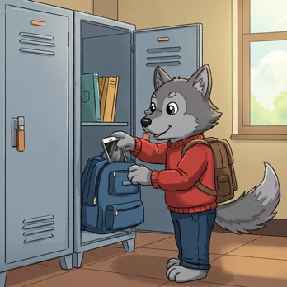
DIGITAL DEVICE POLICY
In January 2024, the Ministry of Education and Child Care mandated all school boards in British Columbia to update their Codes of Conduct to include restrictions on students’ personal digital device use. Students should not have personal digital devices (phones, tablets, smart watches, or computers) in their possession during the school day unless permission is granted by the supervising staff for educational purposes. This includes during recess and lunch or while outside on the playground or on school property. It is recommended that students do not bring personal digital devices to school.


ALLERGY ALERT:
All families should be aware that Whiteside School has many students with severe, life-threatening food allergies. Some classrooms may be designated nut free to protect the health of these students. Please help us limit the nut products entering our school overall, as the impact on a student can happen anywhere in the school. If possible, please do not send food to school containing nuts.


MORNING ROUTINES AT WHITESIDE
Our Wolfpack are expected to enter
school from their outside doors until 8:45 a.m. Please ensure that your children make their way to the back of the school to meet their teachers. This ensures that all children are met by their teacher or supervising adult and can begin the day with their class.
Play n’ Eat is on Friday mornings only. Students who arrive earlier than 8:40 a.m. are welcome to play on the playground or line up early.

Keeping Our Community Clean
There has also been an increase in litter and refuse around our school and local community. We ask for your support in keeping our community clean. These are some ways you can help:
- Reuse reusable snack and lunch containers instead of single-use plastic bags, wrappers, and foil.
- Resuse reusable drink containers too.
- Send “boomerang” lunches – all uneaten food and packaging can be returned home.
- Talk with your children and lead by example:
    - Reinforce proper sorting of waste at home (recycling and compost)
    - Pick up in the park – help pickup litter around South Arm
Thank you for your help!

PLAY n’ EAT – FRIDAY MORNINGS
Our Play n’ Eat breakfast club is on Friday mornings. Students are welcome to join us in the gym at 8:10 a.m. for light snacks and free games.


TRANSLATE OUR SITE
Did you know you can translate our whiteside.sd38.bc.ca website?

