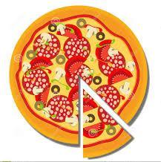
Our first Hot Lunch Day of the 2023-24 school year will be pizza from Yummy Slice Pizza. Please order online by going to the school website whiteside.sd38.bc.ca and clicking on the link under the MunchaLunch icon, or visit https://munchalunch.com/login.

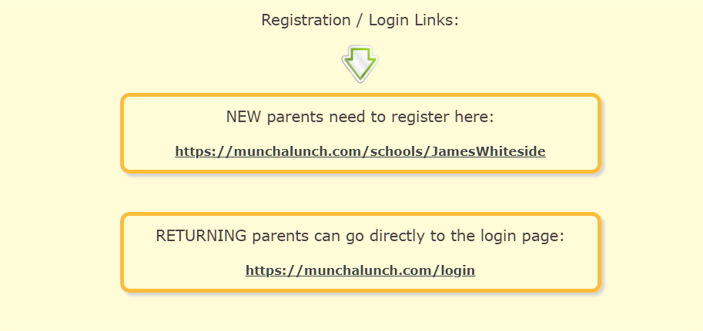

We only accept online orders. If you would like assistance, please email jameswhitehotlunch@gmail.com or leave a message at the office with your name and contact information.
All orders and payment must be received no later than Friday September 15th, 2023.

If your child is absent on this Hot Lunch date and you would like to pick up your child’s order, please inform the office staff when you arrive at the school. All orders must be picked up by 12:30pm. We do not keep the order after this time for food safety and logistical reasons. As with previous years, there are NO REFUNDS as this is a PAC fundraiser. The funds go towards various extracurricular activities and equipment for the students.

Missed ordering? Limited food will be available for students to purchase by cash at the kitchen in the gym while quantities last so please send some food with your child just in case.

Interested in volunteering? Please sign-up at the end of your ordering, or contact us at jameswhitehotlunch@gmail.com. Volunteers will be selected on a rotating basis so everyone will get their turn to volunteer throughout the school year. Please do not show up at the school to volunteer unless you have been contacted by email. Thank you very much for your understanding and support! This program wouldn’t be successful without you!

