FROM OUR WOLFPACK
Div. 4 recently explored the art of mosaics and then put their learning into practice by creating their own mosaic masterpieces using construction paper.
The level of detail, creativity, and sophistication displayed in these pieces is remarkable. Students carefully considered colour, shape, pattern, and composition as they transformed simple materials into stunning works of art. Their patience, perseverance, and attention to detail are evident in every piece. Please see the below for Miriam and Emma’s works of art!
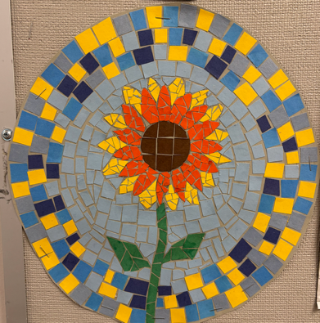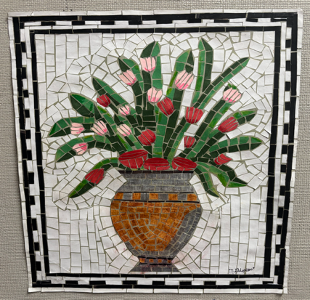

Grade 7 Farewell on June 19, 2026
Grade 7 families and students are preparing the gym for the farewell ceremony this coming Friday. Please see the below for the shape of the day:

Schedule of Events
10:00 a.m. – 11:00 a.m.: Farewell Ceremony
11:00 a.m. – 12:00 p.m.: Photos and mingling outside
12:00 p.m. – 1:00 p.m.: Lunch for students and staff (families can visit outside or come back at 2:45 p.m. for student dismissal)
1:15 p.m. – 2:30 p.m.: Dance
2:30 p.m.: Go back to class for dismissal

PAC MEETINGS
PAC are amazing resources for our entire school community. A strong PAC bonds our school community with our families. PAC is an excellent way for our families to connect directly with the action at our school as well as develop relationships within the parent community. Please reach out to our PAC at whitesidepac@hotmail.com for more information. Our next PAC meeting will be online at 7:45 pm on June 16, 2026 via Teams. This meeting will be the AGM. Please join us!

Move-a-Thon Fundraiser Results
A huge thank you to everyone who participated in and supported our Move-a-Thon fundraiser! Together, we raised an incredible $5,477.90 and surpassed our school-wide goal of $5,000!

Callie (Div.3) and Hudson (Div.12) won $50 gift cards as they were our top individual fundraisers.

Mme Swordy’s class (intermediate) and Mme Kunc’s class (primary) raised the most in the school and have a ice cream sandwich party and 15 minutes extra recess for a whole week!
Because we exceeded our school-wide fundraising goal, students will enjoy a school wide freezie party. Thank you again for your generosity, enthusiasm, and support in making this event such a success! Money raised will go to the painting of the school mural and other PAC supported activities in and around the school (e.g. fieldtrips, classroom resources, school performances).

SUMMER LEARNING 2026
The Summer Learning program and registration dates are now published on our continuing-education website. You can find summer learning 2026 general information on at https://ce.sd38.bc.ca/programs/summer-learning.


LETTER OF LATE RETURN AND EXTENDED ABSENCES
If your child is not able to attend school on Tuesday, September 8, 2026 (the first day of school), but will be returning on or before Friday, September 11th, please complete the Letter of Late Return with the reason for late return to whiteside@sd38.bc.ca by Thursday, June 25th. (Hardcopy forms can be picked up from the office if you do not have a printer.)
Please be advised that the expectations regarding extended absences are different at the beginning of the school year. While extended absences of 20 consecutive school days will normally be considered by the school, the student must be in attendance during September for provincial funding purposes.
If a student does not return on or before Friday, September 11th, we cannot guarantee his or her spot at Whiteside. We are considered a full school and have students in our community on a waitlist. If you arrive after the expected date, your child may need to re-register and be placed at another school upon his or her late return.
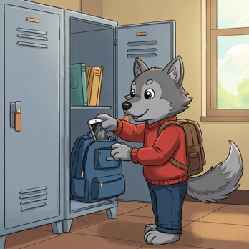
DIGITAL DEVICE POLICY
In January 2024, the Ministry of Education and Child Care mandated all school boards in British Columbia to update their Codes of Conduct to include restrictions on students’ personal digital device use. Students should not have personal digital devices (phones, tablets, smart watches, or computers) in their possession during the school day unless permission is granted by the supervising staff for educational purposes. This includes during recess and lunch or while outside on the playground or on school property. It is recommended that students do not bring personal digital devices to school.


ALLERGY ALERT:
All families should be aware that Whiteside School has many students with severe, life-threatening food allergies. Some classrooms may be designated nut free to protect the health of these students. Please help us limit the nut products entering our school overall, as the impact on a student can happen anywhere in the school. If possible, please do not send food to school containing nuts.


MORNING ROUTINES AT WHITESIDE
Our Wolfpack are expected to enter
school from their outside doors until 8:45 a.m. Please ensure that your children make their way to the back of the school to meet their teachers. This ensures that all children are met by their teacher or supervising adult and can begin the day with their class.
Play n’ Eat is on Friday mornings only. Students who arrive earlier than 8:40 a.m. are welcome to play on the playground or line up early.

KEEPING OUR COMMUNITY CLEAN
There has also been an increase in litter and refuse around our school and local community. We ask for your support in keeping our community clean. These are some ways you can help:
- Reuse reusable snack and lunch containers instead of single-use plastic bags, wrappers, and foil.
- Resuse reusable drink containers too.
- Send “boomerang” lunches – all uneaten food and packaging can be returned home.
- Talk with your children and lead by example:
    - Reinforce proper sorting of waste at home (recycling and compost)
    - Pick up in the park – help pickup litter around South Arm

Thank you for your help!
IMPORTANT DATES
June 16 – K/1, 6/7 Immunizations (VCH)
June 16 – Whiteside PAC AGM @ 7:45 pm on-line
June 17 – Universal Hot Lunch
June 18 – Spirit Day – Wear red and white in support of Team Canada in the World Cup!
June 19 – Grade 7 Farewell
June 25 – Spirit Day – Wear team colours
June 25- Summary of Learning reports published
June 25 – Final day of school for students


WEST COAST RECESS:
During recess and lunchtime breaks, students are expected to be outside at all times this year. Students are strongly encouraged to dress appropriately for the weather. It is more important than ever that students have a spare change of clothes at school. Especially the little ones! Please make sure to include pants, socks, shoes and shirts! Playing outside will ensure our students get some fresh air and exercise to enliven their day.

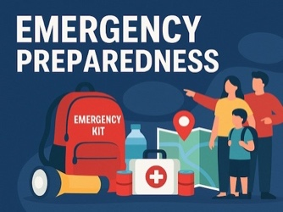
PARENT GUIDE TO EMERGENCY PREPAREDNESS Please visit our school website, whiteside.sd38.bc.ca, to view our district guide to emergency preparedness to better understand our district procedures, emergency drills, communication protocols, and the student reunification process.


TRANSLATE OUR SITE
Did you know you can translate our whiteside.sd38.bc.ca website?

