FROM OUR WOLFPACK
Mr. McCuaig’s class studied climate change and its impact on the environment. Students shared and presented their knowledge, like Vivi!

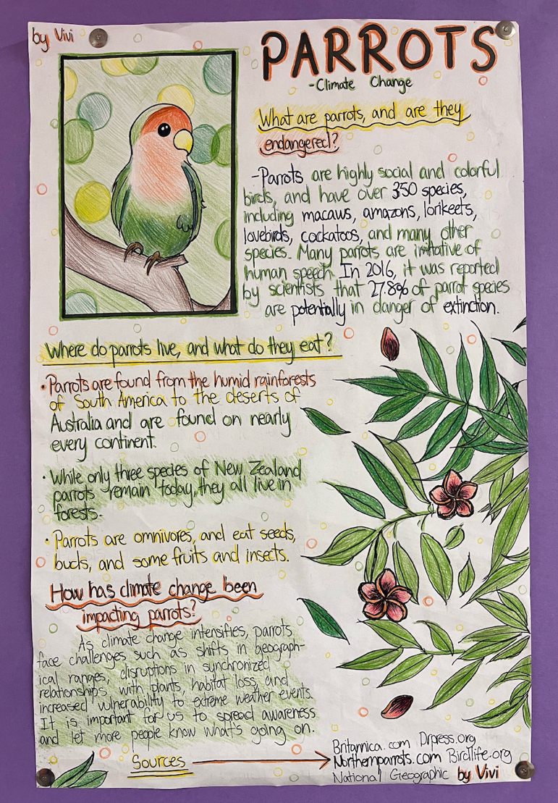

SPORTS DAY ON FRIDAY, JUNE 12: Bike Parade and Pre-School Race

It’s time for our yearly June tradition – SPORTS DAY! Our teams the Orange Creamsicles, Blue Bubblegums, Lime Sherberts and the Red Raspberries are ready to work in their Wolfpacks and have fun! All families are invited to come and cheer us on!

Now get ready to roll and show your school spirit at the annual Whiteside Bike Parade! Students are invited to decorate their bicycles, scooters, roller skates and skateboards in their team colours and join in the fun. Decorated bicycles and scooters may be dropped off in the gym prior to the parade (9:00 am). Please note that electric scooters or e-bikes are not permitted AND safety, helmets are mandatory for all participants—students who do not have a helmet will not be able to participate. We can't wait to see the creativity and excitement on display as our Whiteside Wolves parade their decorated wheels!

In addition, we welcome our little sisters and brothers to join us at 9:10 a.m. on Sports Day for our preschool race. These little ones will line up on our field and run to their families on the other side while all of Whiteside cheers them on.

Lunch will be at approximately 12:10 pm. Families are welcome to enjoy a great hot lunch with their children in South Arm Park. Fun events will continue on until 2 pm!



IMPORTANT: HOT LUNCH VOLUNTEERS NEEDED
Thank you to our PAC for providing yummy hot lunches. We need more volunteers to join us on our PAC hot lunch days to organize and distribute the meals to our students. Without the hard work of this team, our hot lunches can’t happen. If you can help, please email our team at jameswhitehotlunch@gmail.com.

Class Placements and Organization for the 2026-2027 School Year
Our school staff will soon begin thoughtfully planning class placements for the upcoming school year, aiming to create the best learning environment for every child by considering academic, social-emotional, and learning needs, as well as class dynamics.
While specific teacher or friend requests cannot typically be met, parents are invited to share insights into their child’s ideal learning conditions regarding social, emotional, or academic needs. There is also the possibility of changes in our staffing or the levels that our staff teaches. If you wish to provide this valuable input, please email Ms. Lai by Friday, June 5th, 2026..
We appreciate your trust in our professional staff to organize classes for a productive and rewarding year for all students.

PAC MEETINGS
PAC are amazing resources for our entire school community. A strong PAC bonds our school community with our families. PAC is an excellent way for our families to connect directly with the action at our school as well as develop relationships within the parent community. Please reach out to our PAC at whitesidepac@hotmail.com for more information. Our next PAC meeting will be online at 7:45 pm on June 16, 2026 via Teams. This meeting will be the AGM. Please join us!


SUMMER LEARNING 2026
The Summer Learning program and registration dates are now published on our continuing-education website. You can find summer learning 2026 general information on at https://ce.sd38.bc.ca/programs/summer-learning.


LETTER OF LATE RETURN AND EXTENDED ABSENCES
If your child is not able to attend school on Tuesday, September 8, 2026 (the first day of school), but will be returning on or before Friday, September 11th, please complete the Letter of Late Return with the reason for late return to whiteside@sd38.bc.ca by Thursday, June 25th. (Hardcopy forms can be picked up from the office if you do not have a printer.)
Please be advised that the expectations regarding extended absences are different at the beginning of the school year. While extended absences of 20 consecutive school days will normally be considered by the school, the student must be in attendance during September for provincial funding purposes.
If a student does not return on or before Friday, September 11th, we cannot guarantee his or her spot at Whiteside. We are considered a full school and have students in our community on a waitlist. If you arrive after the expected date, your child may need to re-register and be placed at another school upon his or her late return.
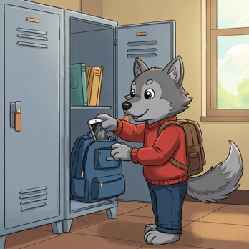
DIGITAL DEVICE POLICY
In January 2024, the Ministry of Education and Child Care mandated all school boards in British Columbia to update their Codes of Conduct to include restrictions on students’ personal digital device use. Students should not have personal digital devices (phones, tablets, smart watches, or computers) in their possession during the school day unless permission is granted by the supervising staff for educational purposes. This includes during recess and lunch or while outside on the playground or on school property. It is recommended that students do not bring personal digital devices to school.


ALLERGY ALERT:
All families should be aware that Whiteside School has many students with severe, life-threatening food allergies. Some classrooms may be designated nut free to protect the health of these students. Please help us limit the nut products entering our school overall, as the impact on a student can happen anywhere in the school. If possible, please do not send food to school containing nuts.


MORNING ROUTINES AT WHITESIDE
Our Wolfpack are expected to enter
school from their outside doors until 8:45 a.m. Please ensure that your children make their way to the back of the school to meet their teachers. This ensures that all children are met by their teacher or supervising adult and can begin the day with their class.
Play n’ Eat is on Friday mornings only. Students who arrive earlier than 8:40 a.m. are welcome to play on the playground or line up early.

KEEPING OUR COMMUNITY CLEAN
There has also been an increase in litter and refuse around our school and local community. We ask for your support in keeping our community clean. These are some ways you can help:
- Reuse reusable snack and lunch containers instead of single-use plastic bags, wrappers, and foil.
- Resuse reusable drink containers too.
- Send “boomerang” lunches – all uneaten food and packaging can be returned home.
- Talk with your children and lead by example:
    - Reinforce proper sorting of waste at home (recycling and compost)
    - Pick up in the park – help pickup litter around South Arm
Thank you for your help!
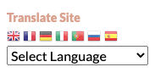
TRANSLATE OUR SITE
Did you know you can translate our whiteside.sd38.bc.ca website?

IMPORTANT DATES
June 8 – Around the World Traditional Games – presented by Div. 1 (gym)
June 10 – Band Concert 1:30 & 6:30 pm
June 11- World Cup Spirit Day – wear black and white
June 12 – Sports Day
June 16 – K/1, 6/7 Immunizations (VCH)
June 16 – Whiteside PAC AGM @ 7:45 pm on-line
June 17 – Universal Hot Lunch
June 18 – Spirit Day – “Beach Day”
June 19 – Grade 7 Farewell
June 25 – Final day of school for students


WEST COAST RECESS:
During recess and lunchtime breaks, students are expected to be outside at all times this year. Students are strongly encouraged to dress appropriately for the weather. It is more important than ever that students have a spare change of clothes at school. Especially the little ones! Please make sure to include pants, socks, shoes and shirts! Playing outside will ensure our students get some fresh air and exercise to enliven their day.

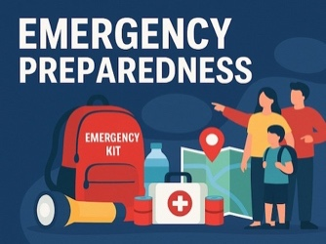
PARENT GUIDE TO EMERGENCY PREPAREDNESS Please visit our school website, whiteside.sd38.bc.ca, to view our district guide to emergency preparedness to better understand our district procedures, emergency drills, communication protocols, and the student reunification process.


UNIVERSAL HOT LUNCH

Utilizing Feeding Futures as well as National School Food Program funding, the Richmond School District has piloted a universal hot lunch program at selected elementary and secondary schools. The Universal Hot Lunch program will continue for the rest of the year. Ordering is now open on munchalunch.com.

