FROM OUR WOLFPACK
Division 11 shared an exciting project that they have been working on.

Cette semaine dans Division 11 nous avons appris comment tricoter avec les petits métiers de tricot. On a regardé un vidéo pour apprendre comment le faire. C’était un peu difficile au début, mais nous avons eu Mme Dennill là pour nous aider. Nous avons tricoté dans les cercles de tricot. C’était très amusant!
À la fin de la semaine nous avons les très longues chaînes qu’on peut utiliser pour les bracelets, les
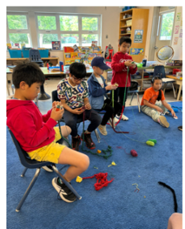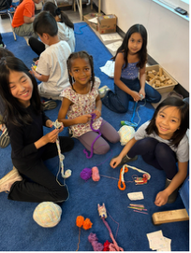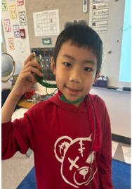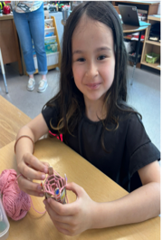
foulards minces ou les décorations. Tu peux le faire aussi!
This week in Division 11 we learned how to knit with the small knitting looms. We watched a video to learn how to do it. It was a little difficult at first, but we had Ms. Dennill there to help us. We knitted in the knitting circles. It was a lot of fun!
At the end of the week we have the very long chains that can be used for bracelets, thin scarves or decorations. You can do it too!
New Principal Coming to Whiteside
It has been announced that Ms. Lesa Schulz will be Whiteside’s new principal effective July 1st, 2026. She is coming from Lord Byng Elementary where she has been principal. We are excited to have her come to Whiteside and join our amazing community.

Ms. Rooney will be moving on to Garden City Elementary as their new Principal. Ms. Lai will continue to stay at Whiteside Elementary as our Vice Principal.

Movathon Fundraiser – Due June 5
Whiteside PAC is organizing a fundraiser to help beautify our school! Sandeep Johal, a renowned muralist, is going to be painting a mural inside the front entrance of the school. We are hoping that she continue this work in the gym as well. To help fund this project, students have brought home a pledge sheet to encourage exercise and movement for a good cause. There are prizes for the students and classes who raise the most funds. Let’s move for Whiteside!

TRACK MEET
Our Whiteside Wolves had a fun experience at our track and field meet with Diefenback Elementary, Maple Lane Elementary and McNeely Elementary schools. We were lucky that we had the perfect weather. All our students

had the chance to run, jump and throw at various stations, competing and/or trying for the first time at Minoru Park.

For families seeking additional opportunities for their child to participate in additional track and field experiences, the Richmond Kajaks Track and Field Club is hosting the BC Elementary Track and Field
Championships on May 22 - 24, 2026. This is an external community-based event hosted at Minoru

and is open to children 9-13 years of age, including those who have no previous experience. More information can be found on https://www.kajaks.ca/bcec

 Next: PAC Hot Lunch Orders Due May 22nd for Hot Lunch Day on May 29th. Go to Munchalunch now!

IMPORTANT: HOT LUNCH VOLUNTEERS NEEDED
Thank you to our PAC for providing yummy hot lunches. We need more volunteers to join us on our PAC hot lunch days to organize and distribute the meals to our students. Without the hard work of this team, our hot lunches can’t happen. If you can help, please email our team at jameswhitehotlunch@gmail.com.


PARENT GUIDE TO EMERGENCY PREPAREDNESS Please visit our school website, whiteside.sd38.bc.ca, to view our district guide to emergency preparedness to better understand our district procedures, emergency drills, communication protocols, and the student reunification process.


SUMMER LEARNING 2026
The Summer Learning program and registration dates are now published on our continuing-education website. You can find summer learning 2026 general information on at https://ce.sd38.bc.ca/programs/summer-learning.


PLAY n’ EAT – FRIDAY MORNINGS
Our Play n’ Eat breakfast club is on Friday mornings. Students are welcome to join us in the gym at 8:10 a.m. for light snacks and free games.


PAC MEETINGS
PAC are amazing resources for our entire school community. A strong PAC bonds our school community with our families. PAC is an excellent way for our families to connect directly with the action at our school as well as develop relationships within the parent community. Please reach out to our PAC at whitesidepac@hotmail.com for more information. Our next PAC meeting will be online at 7:45 pm on June 16, 2026 via Teams. This meeting will be the AGM. Please join us!


UNIVERSAL HOT LUNCH

Utilizing Feeding Futures as well as National School Food Program funding, the Richmond School District has piloted a universal hot lunch program at selected elementary and secondary schools. The Universal Hot Lunch program will continue for the rest of the year. Ordering is now open on munchalunch.com.


IMPORTANT DATES
May 19 – Gr. 7 Day at McRoberts
May 20 – Welcome to Kindergarten event (p.m.)
May 20 – Universal Hot Lunch
May 20-22 – Gr. 6 Camp at Cheakamus Centre
May 22 – Spirit Day – “Animal Day”
May 27 – Jay’s Care Wrap Up Event 9:45 am – 1:15 pm
May 29 – Hot Lunch
June 3 – Universal Hot Lunch
June 12 – Sports Day
June 17 – Universal Hot Lunch
June 18 – Spirit Day – “Beach Day”
June 19 – Grade 7 Farewell
June 25 – Final day of school for students


TRANSLATE OUR SITE
Did you know you can translate our whiteside.sd38.bc.ca website?


WEST COAST RECESS:
During recess and lunchtime breaks, students are expected to be outside at all times this year. Students are strongly encouraged to dress appropriately for the weather. It is more important than ever that students have a spare change of clothes at school. Especially the little ones! Please make sure to include pants, socks, shoes and shirts! Playing outside will ensure our students get some fresh air and exercise to enliven their day.


EXTENDED ABSENCES
During the year students may be absent from school for an extended period. It is district policy that students may only be absent for 4 (four) consecutive weeks and retain their
place in the school. Upon returning, students may have to re-register at the school board office. If Whiteside is full, the district will find space in the nearest available school. Teachers will not provide work for students on extended absences. Our extended absence form needs to be completed if you are planning an absence for a week or longer.

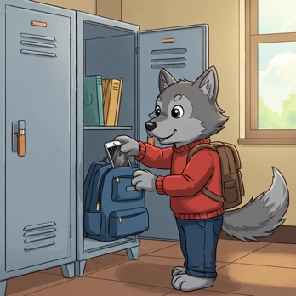
DIGITAL DEVICE POLICY
In January 2024, the Ministry of Education and Child Care mandated all school boards in British Columbia to update their Codes of Conduct to include restrictions on students’ personal digital device use. Students should not have personal digital devices (phones, tablets, smart watches, or computers) in their possession during the school day unless permission is granted by the supervising staff for educational purposes. This includes during recess and lunch or while outside on the playground or on school property. It is recommended that students do not bring personal digital devices to school.


ALLERGY ALERT:
All families should be aware that Whiteside School has many students with severe, life-threatening food allergies. Some classrooms may be designated nut free to protect the health of these students. Please help us limit the nut products entering our school overall, as the impact on a student can happen anywhere in the school. If possible, please do not send food to school containing nuts.


MORNING ROUTINES AT WHITESIDE
Our Wolfpack are expected to enter
school from their outside doors until 8:45 a.m. Please ensure that your children make their way to the back of the school to meet their teachers. This ensures that all children are met by their teacher or supervising adult and can begin the day with their class.
Play n’ Eat is on Friday mornings only. Students who arrive earlier than 8:40 a.m. are welcome to play on the playground or line up early.

